Summer Rolls with Peanut Sauce

Directions

* In a mixing bowl, **stir together** peanut butter, hoisin sauce, and garlic. Once mixed, add in warm water. Set aside.
* **Prepare the rice wrappers.** Pour warm water into a bowl. Dip rice wrapper into warm water for 10-15 seconds and lay it on a pan. Pat to slightly dry.
* Fill the rolls with carrots, cucumber, cabbage, avocado, lettuce leaf, and chicken or shrimp. **Do not overstuff** the wrapper.
* Roll the wrappers **tightly** and lay on the pan.
* Enjoy!!



You will need:

 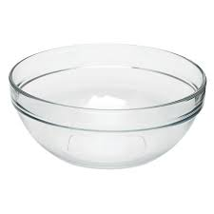  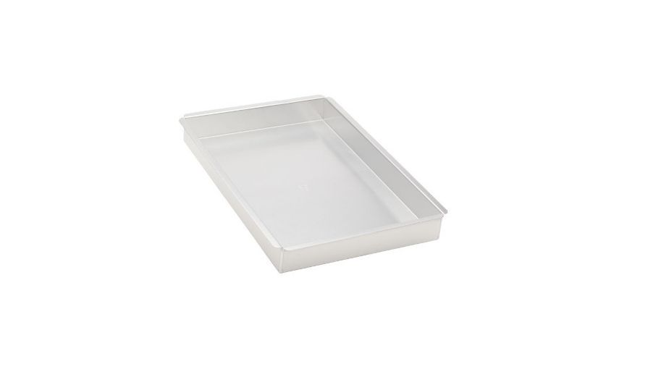

Whisk mixing bowl measuring cups and spoons large pan

S

Ingredients

¼ cup of creamy peanut butter



1 tablespoon hoisin sauce



1 teaspoon of minced garlic



1-2 tablespoons of warm water



10 spring roll rice wrappers



1 large carrot (peeled) and Cucumber (peeled)

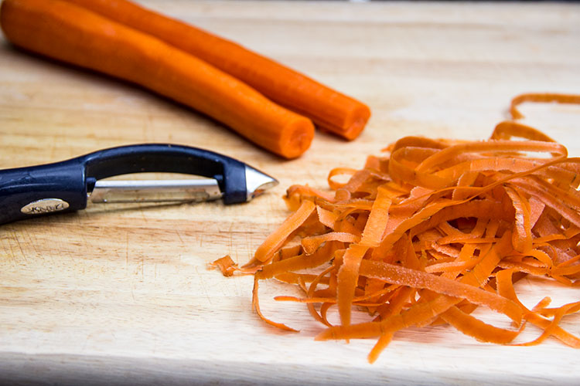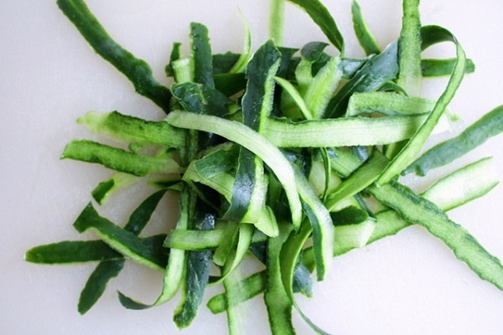

1/3 cup of chopped purple cabbage



1 avocado

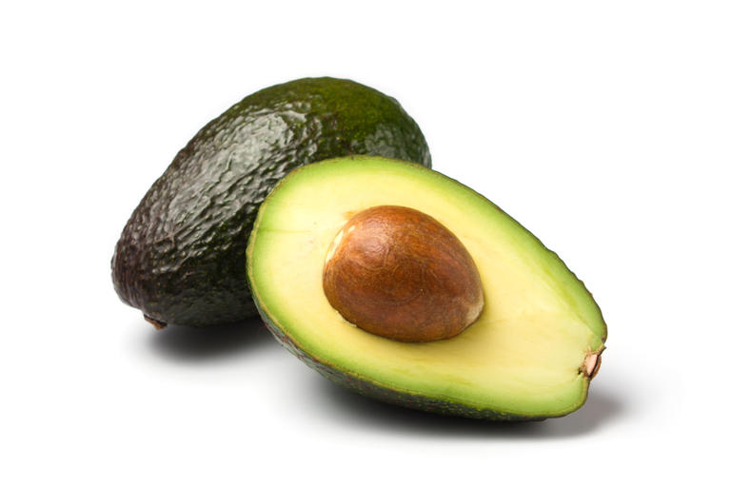

5 large lettuce leaves



Shredded chicken/ cooked shrimp

 